Memo
Date: | June 26, 2026
To: | Juan Portillo, Transit Manager, City of Manteca
From: | Gaby Picado-Aguilar and Jeremiah LaRose, Fehr & Peers
Subject: | Manteca Fixed-Route Redesign Study, FTA Title VI Major Service Change Equity Analysis

Purpose and Regulatory Background
This memorandum documents the service equity analysis conducted for the Manteca Transit proposed network redesign, in accordance with FTA Circular 4702.1B (Title VI Requirements and Guidelines for Federal Transit Administration Recipients, October 2012), 49 CFR Part 21, and Manteca Transit’s adopted 2024 Title VI Program (FY 2024/25–2026/27). The proposed redesign eliminates all existing fixed routes (RT1–RT4) and replaces them with an entirely new route structure (Routes 200–204 and ST Sierra Direct). This constitutes a major service change under FTA Circular 4702.1B, Chapter IV, and independently triggers the public participation requirements of Manteca Transit’s adopted Public Participation Plan, which specifies that those procedures apply when an existing route is proposed for elimination, a new route is established, or a system-wide service hour change exceeds plus or minus 10 percent. A complete network replacement satisfies multiple triggers simultaneously.
The primary regulatory sources governing this analysis are FTA Circular 4702.1B, Chapter IV (Major Service Change Policy, Disparate Impact, and Disproportionate Burden); 49 CFR Part 21 (DOT Title VI regulations); Executive Order 12898 (Federal Actions to Address Environmental Justice in Minority Populations and Low-Income Populations); and FTA Circular 4703.1 (Environmental Justice Policy Guidance for Federal Transit Administration Recipients, August 2012).

Description of Proposed Service Changes
Figure 1 describes the existing and proposed transit service in the City of Manteca. The existing Manteca Transit fixed-route network consists of four routes (RT1, RT2, RT3, and RT4) operating on 60-minute headways, Monday through Saturday for Routes 1 through 3 and Monday through Friday for Route 4. Weekday service operates from 6:00 AM to 6:00 PM (12 hours); Saturday service operates from 9:00 AM to 3:00 PM (6 hours). The ACE Shuttle provides commuter connections to the Lathrop ACE Station on weekdays only, with two morning and four afternoon round trips.

Figure 1. Existing and proposed transit service in the City of Manteca
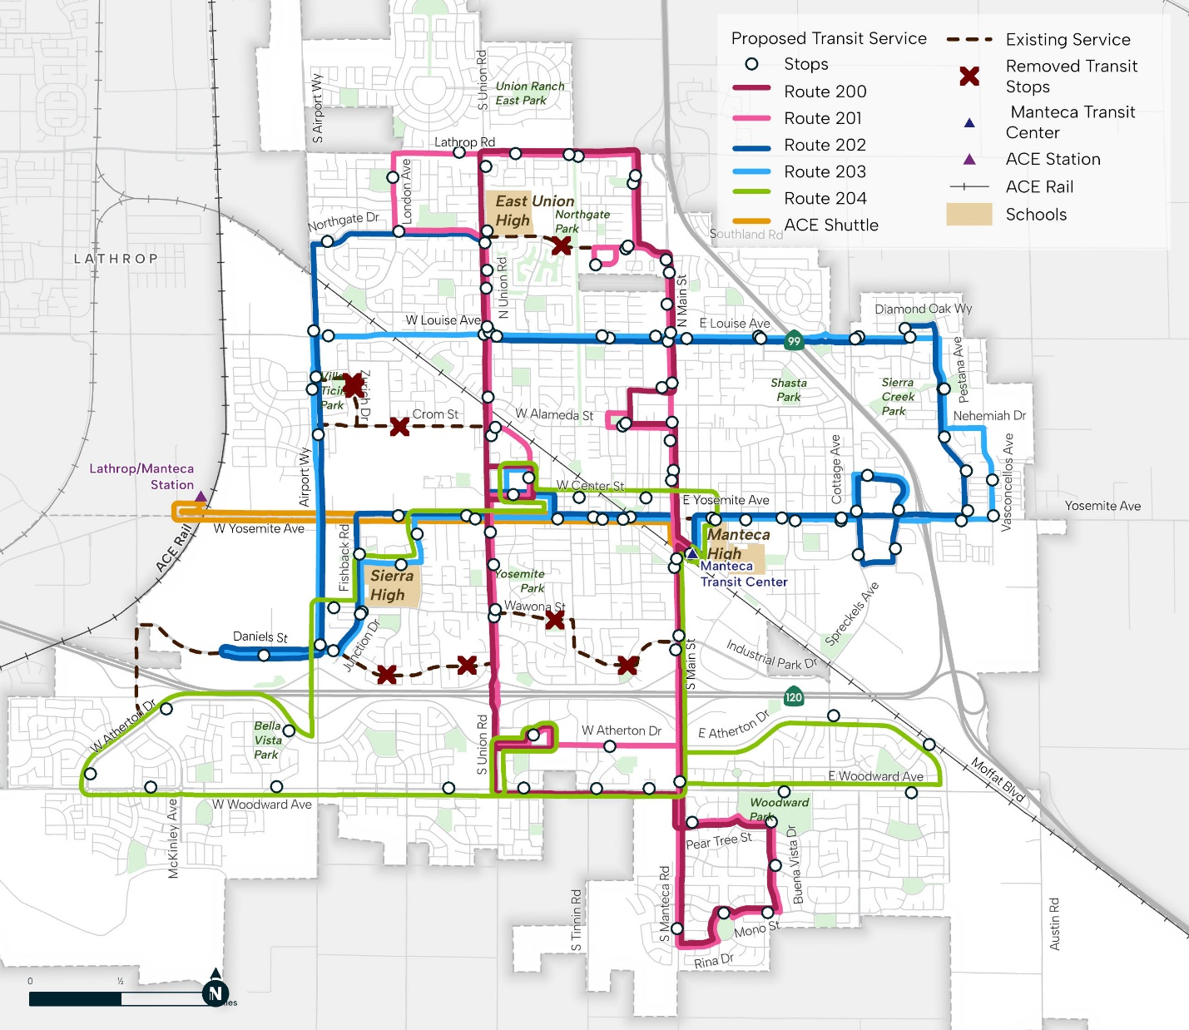
Source: Fehr & Peers, 2026
The proposed network replaces all four existing routes with five new local routes (Routes 200, 201, 202, 203, and 204) and one express service (ST Sierra Direct), with the ACE Shuttle retained with no modifications. Routes 201, 202, and 204 operate Monday through Saturday; Routes 200 and 203 operate Monday through Friday only, consistent with the weekday-only pattern of the existing Route 4. The ST Sierra Direct operates one morning weekday trip aligned with the Sierra High School bell schedule.
While the proposed network involves a complete replacement of the existing route structure, it does not represent a meaningful reduction in geographic coverage. Stop locations on existing routes that are not directly served by the proposed network remain within one-quarter mile walking distance of stops on the new routes, consistent with the proximity threshold used throughout this analysis. Of the 59 block groups analyzed, 57 experience an increase in accessible trips under the proposed network, and the remaining 2 recorded zero trips under both the existing and proposed networks, indicating they fall outside the effective service area under either condition. No block group within the service area experiences a net loss of service as a result of the proposed redesign.
The proposed network substantially expands the span of service. On weekdays, service spans from approximately 5:32 AM to 8:58 PM, approximately 15.5 hours compared to 12 hours under the existing network, an increase of approximately 3.5 hours. On Saturdays, service on Routes 201, 202, and 204 spans from approximately 8:32 AM to 6:58 PM, approximately 10.5 hours compared to 6 hours under the existing network, an increase of approximately 4.5 hours. Headways remain at 60 minutes throughout.
At the system level, the proposed network represents a substantial increase in service availability. Annual trips within a one-quarter mile buffer of the service area increase from 16,965 under the existing network to 27,655 under the proposed network, a net increase of 10,690 annual trips, or approximately 63 percent.

Agency Policy Thresholds
FTA Circular 4702.1B requires that recipients formally adopt definitions for (1) what constitutes a major service change, (2) the threshold at which an adverse impact on minority populations constitutes a disparate impact, and (3) the threshold at which adverse impacts on low-income populations constitute a disproportionate burden.
Manteca Transit’s 2024 Title VI Program identifies participation triggers for major service changes, including the elimination of any existing route, the establishment of any new route, and any system-wide service hour change exceeding plus or minus 10 percent. However, the program does not include formally adopted numeric thresholds for disparate impact or disproportionate burden findings as required by Circular 4702.1B Section 4.4. In the absence of formally adopted thresholds, this analysis applies the comparative methodology described in Circular 4702.1B, assessing whether the share of service change experienced by minority or low-income populations is disproportionate relative to the service area average.

Study Area and Demographics
The study area consists of 59 Census block groups covering the Manteca Transit service area, show in Figure 2. The total study area population is approximately 100,836 persons.
Demographic data are drawn from the U.S. Census Bureau American Community Survey (ACS) 5-year estimates. Minority populations are defined per Circular 4702.1B as persons who identify as American Indian or Alaska Native, Asian, Black or African American, Hispanic or Latino, Native Hawaiian or Other Pacific Islander, or multiracial (non-white). Low-income populations are defined as persons at or below 100 percent of the Census-defined federal poverty level, consistent with the threshold adopted in Manteca Transit’s 2024 Title VI Program.
The service area demographic benchmarks are 65.3 percent minority and 9.6 percent low-income. These benchmarks serve as the basis for comparison in the disparate impact and disproportionate burden analyses.

Figure 2. Census block groups in the City of Manteca
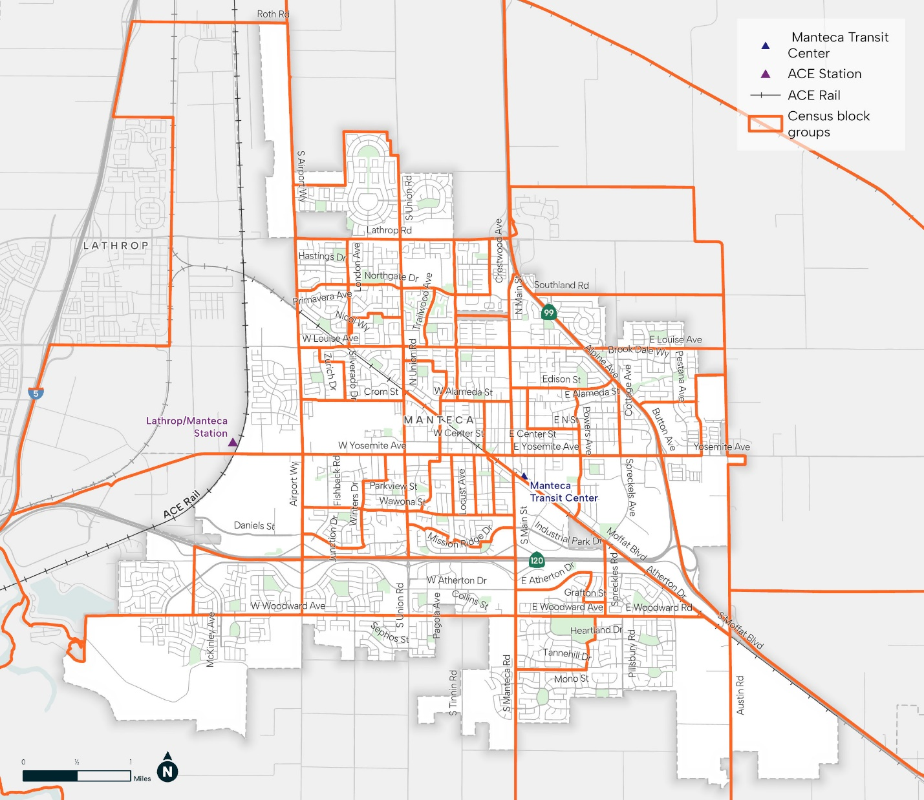
Source: Fehr & Peers, 2026

Methodology
Service levels are measured using annual transit trips accessible within a one-quarter mile walking distance buffer of each Census block group centroid, for both the existing and proposed networks. This metric is consistent with guidance in FTA Circular 4702.1B and TCRP Report 196 (A Practitioner’s Guide to Understanding and Applying Title VI in Transit Agency Service and Fare Decisions, 2021). The analysis was conducted using Remix’s automated Title VI analysis tool (v2.0), which applies this methodology at the block group level using the ACS demographic data described in Section 4.
The disparate impact and disproportionate burden tests follow the comparative approach described in Circular 4702.1B: the share of the service change experienced by minority populations is compared to the service area minority average, and the same comparison is performed for low-income populations. Because the proposed network produces a net service increase, the analysis assesses whether the benefit of that increase is distributed proportionately relative to service area demographics.

Disparate Impact and Disproportionate Burden Findings
Table 1 summarizes service area-level before and after conditions and the share of the service change experienced by each demographic group.
Table 1. Service Area Summary: Before/After Comparison by Demographic Group
Metric | Before | After | Change | Service Area Average
Service Population (with ¼ mile) | 47,738 | 55,492 | +7,754  (16%)
Annual Trips (System) | 16,965 | 27,655 | +10,690 (+63%) | —
Share of Change Experienced by Minority Populations | — | — | 67.2% | 65.3%
Share of Change Experienced by Low-Income Populations | — | — | 10.8% | 9.6%
Source: Remix Title VI Analysis v2.0; U.S. Census Bureau ACS 5-Year Estimates.

Disparate Impact (Minority Populations)
Minority populations experience a 67.2 percent increase in service resulting from the proposed network redesign, compared to a service area minority average of 65.3 percent. The difference of 1.9 percentage points indicates that minority populations receive a proportionately slightly larger share of the service benefit. Because the overall change is a net increase in service, this finding represents a marginal positive effect, not an adverse impact. Based on a comparative assessment in the absence of adopted thresholds, the analysis does not indicate evidence of disparate impact.

Disproportionate Burden (Low-Income Populations)
Low-income populations experience a 10.8 percent increase in service resulting from the proposed network redesign, compared to a service area low-income average of 9.6 percent. The difference of 1.2 percentage points indicates that low-income populations receive a proportionately slightly larger share of the service benefit. Because the overall change is a net increase in service, this finding represents a marginal positive effect, not an adverse impact. Based on a comparative assessment in the absence of adopted thresholds, the analysis does not indicate evidence of disparate impact.

Public Participation
Manteca Transit conducted an extensive public participation process throughout the development of the proposed network redesign, consistent with the requirements of FTA Circular 4702.1B and the agency’s adopted Public Participation Plan. Outreach activities included the following:
- Two in-person public workshops held at the outset of the planning process (January 29, 2026, with sessions at 12:00 PM and 6:00 PM) to introduce the project and gather initial community input.
- Two in-person public workshops held to present service concepts and collect feedback (May 11, 2026, with sessions at 12:00 PM and 6:00 PM).
- One virtual public workshop held via Microsoft Teams (June 3, 2026, at 12:00 PM).
- On-board and online public surveys, as well as driver surveys, to gather input from existing riders and the broader community.
- Targeted community outreach at senior-serving facilities, including a Senior Center lunch event and Eskaton Senior Living (May 13, 2026).
- Booth presence at community events to engage a broad cross-section of the public, including the Memorial Weekend event (Saturday, May 25, 2026), Maple on Music (May 21, 2026), and the Watermelon Street Faire (June 6 and 7, 2026).
Outreach boards and surveys were translated into Spanish, consistent with the Language Assistance Plan included in Manteca Transit’s 2024 Title VI Program. This record of outreach, conducted across multiple formats and venues over the course of the planning process, constitutes meaningful public participation as required by FTA Circular 4702.1B. Outreach activities were designed to reach a broad cross-section of the community, including minority, low-income, and senior populations.
In addition to the foregoing, a formal public hearing is recommended prior to City Council consideration of the proposed network. The draft plan will be made available for public review at least 30 days before the hearing. This memorandum and the supporting equity analysis will be available for public review during that period. Comments received at the public hearing and the agency’s responses should be documented and appended to the Plan upon completion of the process.

Conclusion and Recommended Next Steps
The proposed Manteca Transit network redesign constitutes a major service change under FTA Circular 4702.1B and Manteca Transit’s adopted Public Participation Plan. The service equity analysis finds no disparate impact on minority populations and no disproportionate burden on low-income populations. Both groups receive a proportionately equal or slightly larger share of the net service benefit resulting from the redesign.
The following actions are recommended prior to finalization of the service change:
- Manteca Transit should formally adopt numeric disparate impact and disproportionate burden thresholds as required by FTA Circular 4702.1B Section 4.4, preferably through City Council adoption or a program amendment to the 2024 Title VI Program, prior to or concurrent with adoption of the service change.
- The equity analysis findings should be made available for public review during the comment period.
- This documentation should be incorporated into Manteca Transit’s next Title VI Program submission to FTA (due June 2027) and maintained as a standalone public record per Circular 4702.1B requirements.

