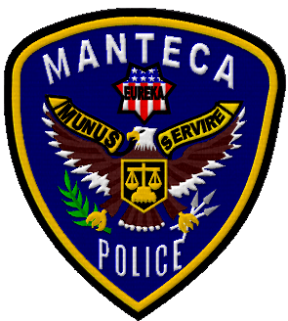
Chief’s CSI Academy Application
Manteca Police Department
1001 West Center Street
Manteca, Ca 95337
(209) 456-8100
June 1st thru June 11th 2021
For 5th grade – 6th grades. (Grade student will be attending). Spaces are limited, (20 applicants) fill quickly and spots will be
given to new applicants first.
Parents, have your child fill out the application to the best of their ability. Communication will be primarily through parental email, please check your email, including spam after the closing date.
• The information you provide in this application will be used in the background investigation to assist
in determining your suitability for the position of Cadet.
• Type or neatly print, in ink, responses to all items and questions. If a question does not apply to you, write “N/A” (not applicable) in the space provided for your response. If you cannot obtain or remember certain information, indicate so in your response.
• If you need more space for any response, use the last page and identify the additional information by the question number.
- Deadline for this application must be turned in by April 20th. Scan and email application to asmith@ci.manteca.ca.us or turn it into the Manteca Police Department.
Be as complete, honest and specific as possible in your responses.
Personal
Full Name_________________________________________________
Address ___________________________ City __________________
Date of Birth _________________
School you attend ______________________ Grade _______
Shirt Size: ______________ (specify youth or adult)
Parents name____________________Email_____________________
Parents Cell __________________ Home Phone__________________

For more information, please contact Officer April Smith (209) 456-8208 or email at asmith@ci.manteca.ca.us. You may fill out the application online and email it back to me, scan and email it back or fill it out and turn it in to the Police Department, 1001 W. Center St. attention Officer A. Smith.

Chief’s Foundation Jr. CSI Academy


Dates:
June 1st - June 11th, 2021 (grades 5th & 6th)
8am-2pm

This is a parapolice academy, information will be provided. Parents and cadets will be explained the program and a parent/cadet project that must be completed prior to graduation.

- Drill Instructors: Ofc. A. Smith, Ofc. A. Garcia, Ofc. B. Delgado
- Crime Scene Processing
- K-9 Demo
- Life Lessons
- Patrol Demo
- SWAT Demo
- Bomb Unit
- CRT
- Marching/Physical Training
- Traffic Unit
- Drone
- Animal Control
- Manteca Fire

